**Spelling or bugs that need to be fixed iOS/Android/Webpage**

iOS/Android (red coloured are incorrect)

Shop-> Top right corner -> Filters -> price_sorting, price_range -> Needs to be with proper filters pricing filters, product filters oldest, newest.

On webpage there are My sizes option after sign up, there are no My sizes option in apps Profile -> Overview

In apps Profile -> my_items -> MY ITEMS

Profile -> Overview -> Some of options are with capital letters some of them only starting with capital letter. Make all of them with big letters. For example, Post Ads -> POST ADS

Profile -> Wish List -> Back button is not working you have to close the app to get back to main page

Profile -> Overview -> Just keeps loading nothing happens

Ad Details -> Follow buttong is not working

Ad Details -> Send Message -> No back button and you can not send a message.

Quick Responder and Trusted Sellers icons? How do clients earn them?

1. shop page filtering is not working
2. wishlist a error -> request not found
3. wishlist theke back a asle screen black
4. regular price and sell price problem in details page

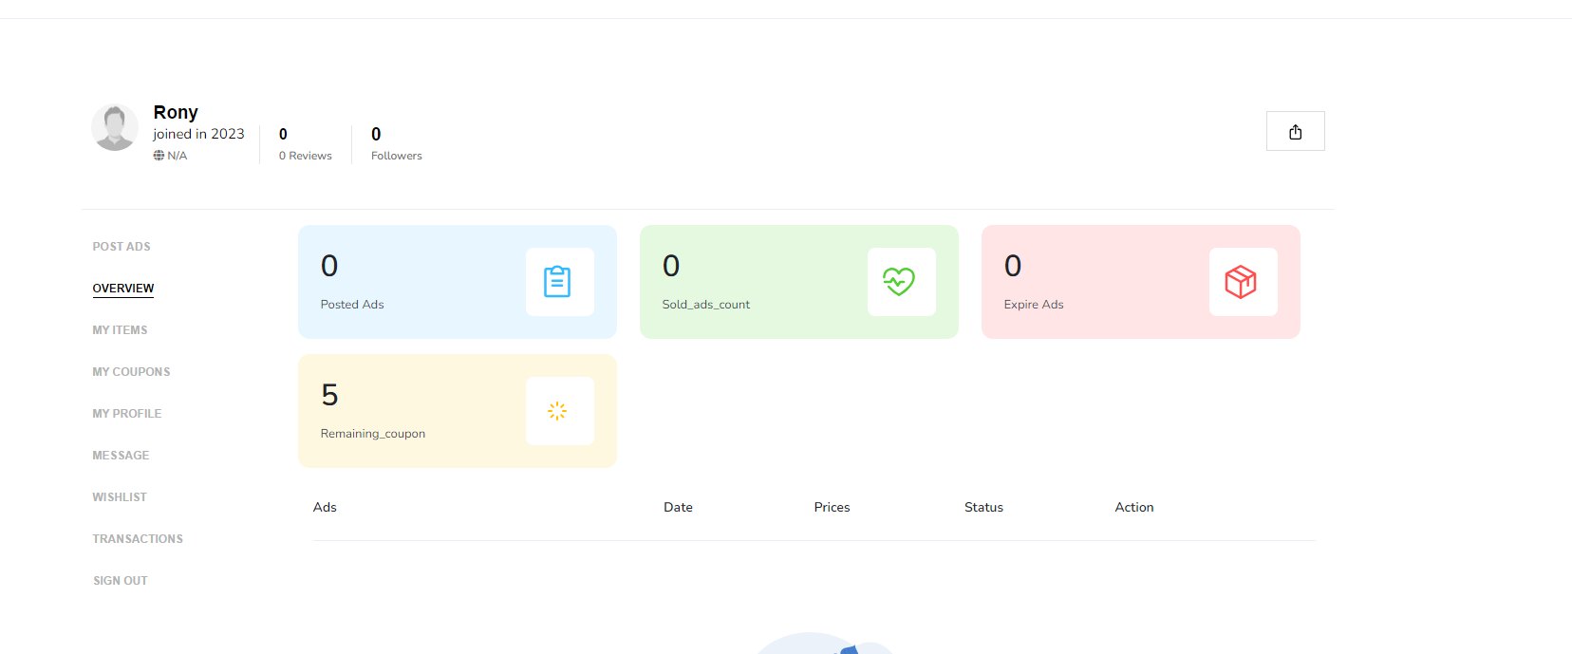

1. overview need to check properly.
2. overview page theke profile edit page a gele request not found
3. details page a phone number
4. details page a seller username and follow is not working
5. details page a tags is not same and seller photo is missing
6. chat box fixing
7. ads mark as sold is not working and delete a alert dite hobe
8. user profile a ads photo show kortace na
9. seller dashboard a ads list a price problem
10. my_items menu problem
11. coupon purchase korar por coupon page a redirect hobe
12. paypal payment ar por coupon page a redirect hoise but kono success message nai
13. kaj korar somoy dekbe kono langaues issue thakle
14. wishlist page a items golo selected thakbe and heart icon a hit korle remove howa jabe
15. login with facebook and gmail need to check and api key panel theke api dia asbe
16. pull to refreash
17. follow